图表

**Supplementary Figure 1.** Expression analysis of NLRP3 inflammasome-regulated genes. Expression profiles of LPS-regulated genes. n = 6 biological replicates. * (p < 0.05) and *** (p < 0.005).

**Supplementary 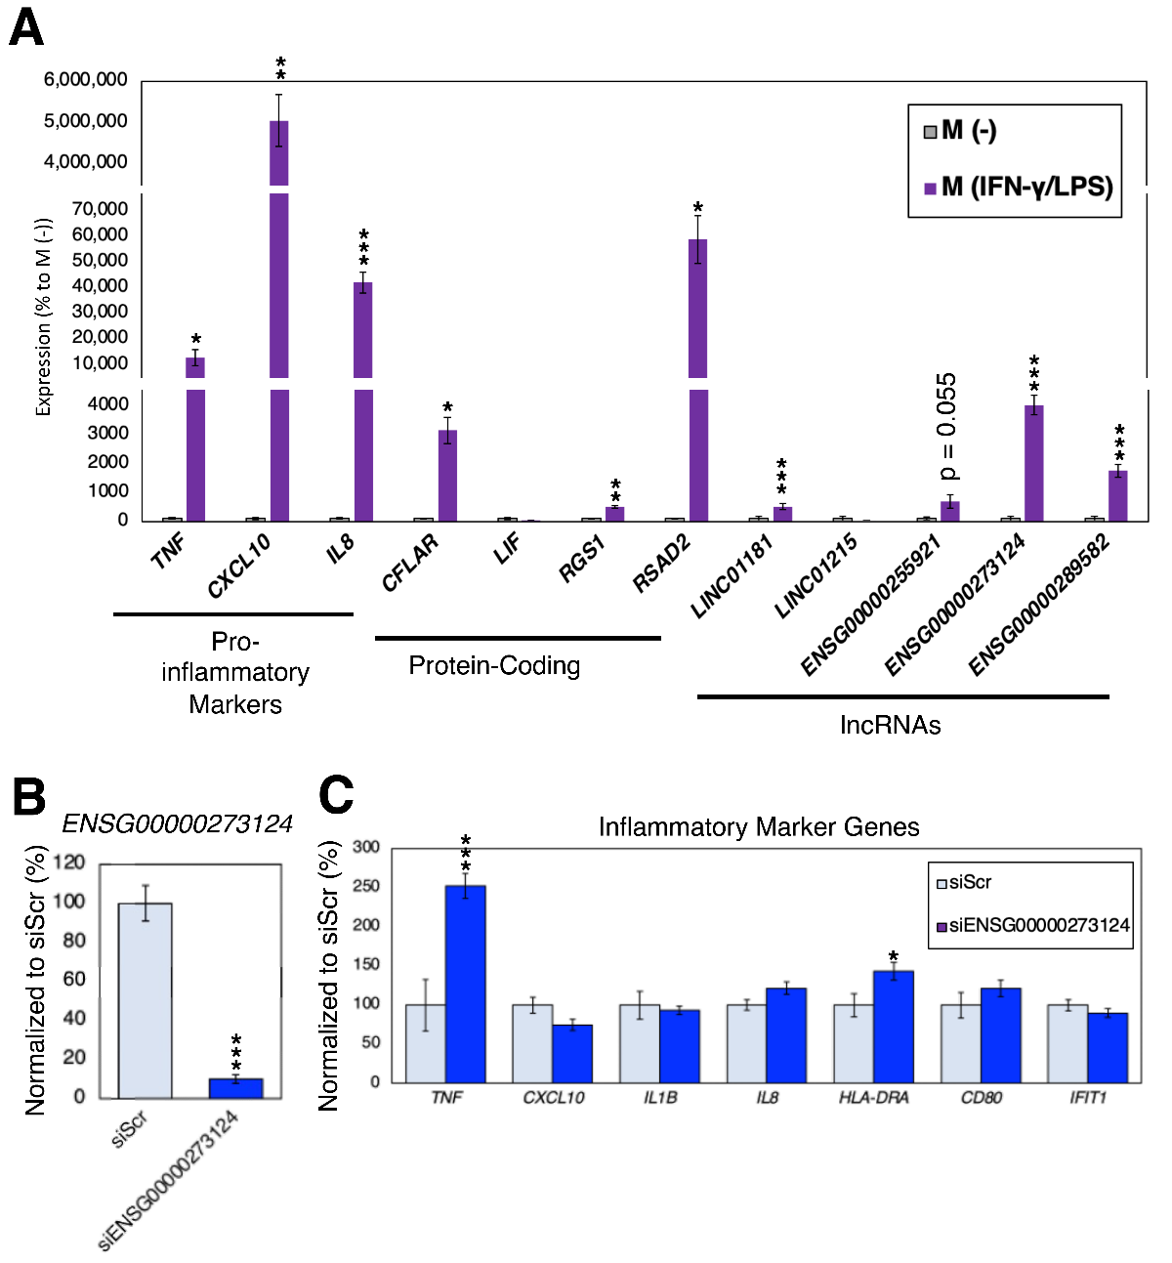Figure 2.** Expression analysis in pro-inflammatory macrophages. (**A**) Expression analysis of pro-inflammatory markers, inflammasome-regulated protein-coding and lncRNA genes. The data were normalized to the expression of M (-) cells. n = 6 biological replicates. * (p < 0.05), ** (p < 0.01) and *** (p < 0.005). (**B**) Silencing of *ENSG00000273124*. The siRNA against random sequence (siScr) was used as control. n = 6 biological replicates. (**C**) Expression analysis of pro-inflammatory markers. n = 6 biological replicates.

**Methods**

*1.1. Cell Culture*

The human leukemia monocytic cell line, THP-1 (LGC Standards GmbH (Wesel, Germany) #ATCC-TIB-202; Lot #70043382), was cultured in the growth medium consisted of RPMI 1640 Medium (Thermo Fisher Scientific (Roskilde, Denmark) #21875091) supplemented with 10% fetal bovine serum (Merck Life Science (Espoo, Finland) #F4135), 1% L-Glutamine solution (Merck Life Science, #G7513), and 1% Penicillin-Streptomycin (Merck Life Science, #P4333). The cells were maintained at a temperature of 37 °C with a 5% CO2 atmosphere.

To differentiate the THP-1 cells into macrophage-like cells (designated as M (-)), they were exposed to a growth medium containing 100 nM of phorbol 12-myristate 13-acetate (PMA; Sigma-Aldrich, #P8139-1MG) for a duration of 3 days. Then, to activate NLRP3 inflammasome, the M (-) cells were incubated with a growth medium supplemented with 250 ng/ml of eBioscience Lipopolysaccharide (LPS) Solution (500X concentration; 2.5 mg/mL) (Thermo Fisher Scientific, #00-4976-93). The derived cells were designated as M (LPS).

To induce pro-inflammatory macrophage activation, M (-) were incubated with the growth medium supplemented with 20 ng/mL of recombinant human interferon-γ (IFN-γ; Cell Signaling, #80385) and 250 ng/mL of eBioscience Lipopolysaccharide (LPS) Solution (500X; 2.5 mg/mL) (Thermo Fisher Scientific, #00-4976-93) for 48 h to derive activated macrophage-like cells (M (IFN-γ/LPS)).

To silence the expression of the target lncRNA gene, *ENSG00000273124*, siRNA was designed with RNAXS (<http://rna.tbi.univie.ac.at/cgi-bin/RNAxs/RNAxs.cgi> accessed on 19 June 2023) and synthesized at Merck Life Science as MISSION siRNA: target sequence, CAGTCCTAGCCAATGAATA; sense - CAGUCCUAGCCAAUGAAUA[dT][dT]; and antisense - UAUUCAUUGGCUAGGACUG[dT][dT]. As a control, Mission Negative control SIC-002 (with a confidential sequence) obtained from Merck Life Science was used. To initiate gene silencing, siRNA transfection was performed on the M (LPS) cells 30 minutes after the activation of NLRP3 inflammasome. The final concentration of siRNA used was 50 nM using Lipofectamine™ RNAiMAX Transfection Reagent (Thermo Fisher Scientific, #13778150) as the transfection agent, following the manufacturer's protocol. After siRNA transfection, the samples were collected 48 hours later for total RNA isolation and further analysis.

*1.2. Isolation of Total RNA and RT-PCR*

To isolate and purify total RNA, the TRIzol Reagent (Thermo Fisher Scientific, Roskilde, Denmark, #15596018) was employed following the manufacturer's instructions. For the synthesis of first-strand complementary DNA (cDNA), the SuperScript IV VILO Master Mix with ezDNase Enzyme (Thermo Fisher Scientific, #11766500) was used to digest the genomic DNA and reverse transcribe the total RNA. Following the reverse transcription reaction, the cDNA samples were diluted with DNase/RNase-free water to a concentration of 1 ng/μL.

For quantitative reverse transcription polymerase chain reaction (qRT-PCR), each reaction utilized 1 ng of cDNA template. The qRT-PCR reaction was carried out using the PowerUp SYBR Green Master Mix (Thermo Fisher Scientific, #A25777) on the QuantStudio 6 Flex Real-Time PCR System (Thermo Fisher Scientific). The annealing temperature during amplification was set to 60 °C. Relative fold expression was calculated using the 2^-ΔΔCt method, with ribosomal protein lateral stalk subunit P0 (*RPLP0*) serving as the internal control.

The primer pairs for qRT-PCR were designed using Primer3 (<http://bioinfo.ut.ee/primer3-0.4.0/>; accessed on 10 June 2023). Before extensive testing, the primer pairs were validated *in silico* using the UCSC In-Silico PCR tool (<https://genome.ucsc.edu/cgi-bin/hgPcr>; accessed on 10 June 2023). Additionally, conventional RT-PCR reactions were performed to verify the primer specificity, followed by gel electrophoresis to confirm the presence of a single band of the expected size for each primer pair. Please refer to Supplementary Table 1 for the primer sequences.

**Supplementary Table 1. List of primers used in this study.**

|  |  |  |  |
| --- | --- | --- | --- |
| **Gene** | **Forward Primer** | **Reverse Primer** | **Expected PCR Product Size (bp)** |
| *RPLP0* | TCGACAATGGCAGCATCTAC | ATCCGTCTCCACAGACAAGG | 191 |
| *IL1B* | GCCCTAAACAGATGAAGTGCTC | GAGATTCGTAGCTGGATGCC | 76 |
| *NLRP3* | TGGCTGTAACATTCGGAGATTG | GAAGTCACCGAGGGCGTTGT | 136 |
| *CASP1* | TGCTCTTCCACACCAGATAATGT | CCACATCACAGGAACAGGCATA | 109 |
| *LIF* | GTTCCCCAACAACCTGGAC | AGGTGCCAAGGTACACGACT | 125 |
| *RGS1* | TGCTACTATTGCTTGTCGGTGT | TCTGACTCCCTGGTTTTAAGAGC | 106 |
| *RSAD2* | TCCACACAGCCAAAACATCCT | CTTGCCCAGGTATTCTCCCC | 143 |
| *CFLAR* | CTATGTGGTGTCAGAGGGCC | GCAGTACACAGGCTCCAGAA | 147 |
| *ENSG00000273124* | GCCCTGCTGACACTTCGA | TCATTGGCTAGGACTGCTGTAAC | 115 |
| *LINC01181* | ACCCATTTCAGAGACCCAGC | CCTCCAAAAGCTTCCACTACCT | 100 |
| *LINC01215* | CGCTTTGATCCTCTGCTTGC | CCCTTGGTTTCGGTTGTTGG | 118 |
| *ENSG00000289582* | CAGACCACGAGCCCACTG | GGGTTGGTAGTATTGCTGGCT | 115 |
| *ENSG00000255921* | CTCTCCCAGCCCGAAGATTC | AACCGTGTCATTTGCTTGCAA | 109 |